



**023**

### Puppy Spot

**Faizan And Waseem**

**Faculty: Sir Barran Patric**

\\\



**Index**

1. **Introduction**
2. **Objectives**
3. **Problem Statement**
4. **Hardware/ Software Requirements**



**Introduction**

The thirst for learning, upgrading technical skills and applying

the concepts in real life environment at a fast pace is what the

Industry demands from IT professionals today. However busy

work schedules, far-flung locations, unavailability of convenient

time-slots pose as major barriers when it comes to applying the

concepts into realism. And hence the need to look out for

alternative means of implementation in the form of laddered

approach.

The above truly pose as constraints especially for our students

too! With their busy schedules, it is indeed difficult for our

students to keep up with the genuine and constant need for

integrated application which can be seen live especially so in the

field of IT education where technology can change on the spur of

a moment. *Well, technology does come to our rescue at such*

*times!!*

Keeping the above in mind and in tune with our constant

End eavour to use Technology in our training model, we at Aptech

have thought of revolutionizing the way our students learn and

implement the concepts using tools themselves by providing a

*live and synchronous eProject learning environment!*

**So what is this eProject?**

eProject is a step-by-step learning environment that closely

simulates the classroom and Lab based learning environment into

actual implementation. It is a project implementation at your

fingertips!! An electronic, live juncture on the machine that allows

you to

* Practice step by step i.e. laddered approach.
* Build a larger more robust application.
* Usage of certain utilities in applications designed by user.
* Single program to unified code leading to a complete application.
* Learn implementation of concepts in a phased manner.
* Enhance skills and add value.
* Work on real life projects.



* Give a real life scenario and help to create applications more complicated and useful.
* Mentoring through email support.

The students at the centre are expected to complete this e Project

and send complete project along with the documentation to eProjects

Team Looking forward to a positive response from your end!!



**Problem Statement**

The PATRONA puppy website is a website which is actually encyclopedia about all

types Of dogs. The Famous Veteran Patron a is fond of animals specially Dogs,

Cats, Rabbits. With her achievements in the field of serving as veteran, she also had

interest in writing books on animals and their behavior. All those years she had

came across various type of breeds and their characteristics and behavior. Due to

passion of photography she has huge collection of animals pictures of all types

discovered. Ms Patron a wish to share this images with all for which she had decided

to develop an website of various animals.

A Website on Dog was proposed to be developed which will show all the type of dogs

found in which location, their behavior, characteristics and so on The website

developed must have the arrangement of the animal’s country wise, type wise,

breed wise.

**Requirements**

The Web site is to be created based on the following requirements.

1. The name of the website and its motto must be mentioned in the home page.
2. The entire navigational link must be mentioned in the home page, using of Crum navigational link wherever necessary.
3. Different types of puppies and dogs must be mentioned in the website.
4. Sorted by different types of categories like country, type.
5. For each animal, certain behavior must be added.
6. Images collection must be added in the gallery section.
7. Extra links like food, nutrition tips for the dogs and so on.
8. Query link must be added to ask the questions.



**Objectives of the project**

The Objective of this program is to give a sample project to work on real life projects.

These applications help you build a larger more robust application.

The objective is not to teach you JavaScript/Dreamweaver but to provide you with a

real life scenario and help you create basic applications using the tools.

You can revise the chapters before you start with the project.

This project is meant for students who have completed the module of *Dreamweaver*.

These programs should be done in the Lab sessions with assistance of the faculty if

required.

It is very essential that a student has a clear understanding of the subject. Students

should go through the project and solve the assignments as per requirements given.

Kindly get back to eProjects Team in case of any doubts regarding the application or its

objectives.



**Hardware/ Software Requirements**

**Hardware**

* **A minimum computer system that will help you access all the tools in the courses**

**is a Pentium 166 or better.**

* **64 Megabytes of RAM or better.**

.

**Software *[Either or Combination as per Course/Sem]***

* **Notepad/HTML editor/Coffee Cup.**
* **Angular / Angular JS / React / Bootstrap.**
* **Dreamweaver / Figma.**
* **MS IE / Chrome / Fire Fox / Netscape /MS Edge.**



###### User Home Page UI:





User Dashboard UI 1



# Project Plan

##### Phase 1: Planning (2 hours)

* Define project objectives, scope, and deliverables
* Identifying requirements
* Conduct feasibility study and analyze the technical requirements
* Allocate project team members and identify roles and responsibilities

##### Phase 2: Design (2 hours)

* Develop user personas and user stories
* Create information architecture and site maps
* Create database
* Develop a project plan that identifies the dependencies and timelines



##### Phase 3: Development (12 hours)

* Set up development environment and establish coding standards
* Develop the front-end of the web application
* Develop the back-end of the web application, including the database and API
* Integrate third-party services, if necessary
* Conduct unit testing and code review

##### Phase 4: Testing (1 hour)

* Conduct functional testing to ensure the web application meets the requirements
* Conduct performance and load testing to identify potential bottlenecks
* Conduct security testing to ensure the web application is secure



##### Phase 5: Deployment (1 hour)

* Deploy the web application to the production environment
* Set up production environment and establish monitoring tools
* Conduct post-deployment testing and debugging
* Prepare user documentation and training materials

##### Resources Required:

* Project Manager
* UI/UX Designer
* Front-end Developer
* Back-end Developer
* Database Administrator
* Technical Writer



Testing & Quality Assurance

Contact Us:

Query Form:

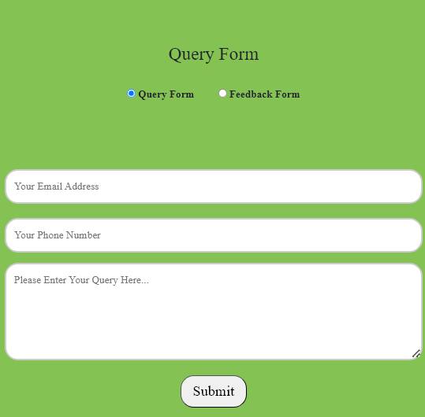

A user is asked to fill any question for Website purpose.



Feedback Form:

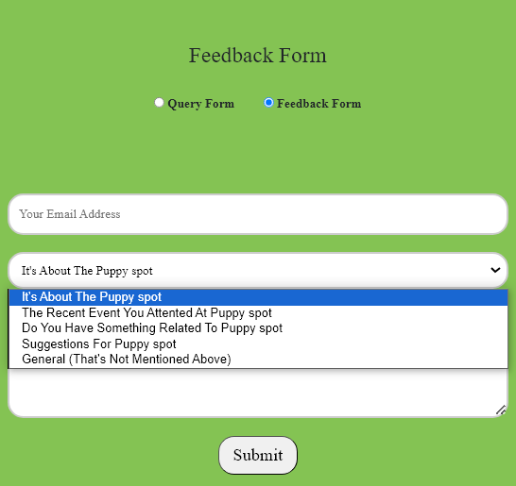

A user is asked to fill any Feedback for Website purpose.



Dogc categories:

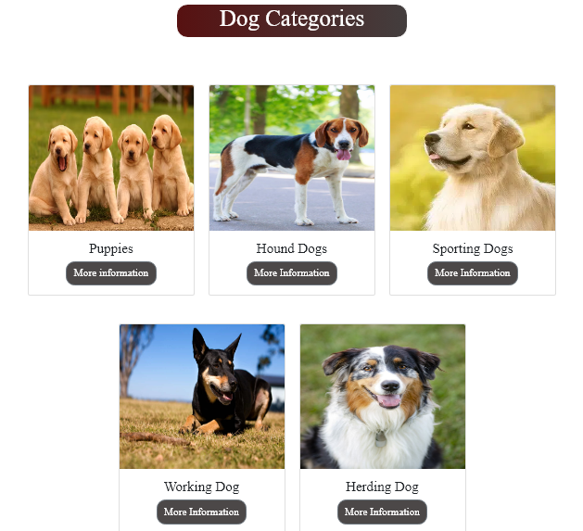

A user is asked to more information for dogs categories.



# **Puppies Nutrition Tips**

1. **Balanced Nutrition: Puppies require a balanced and nutritious diet to support their**

**rapid growth and development. Look for high-quality puppy food that meets the**

**specific nutritional needs outlined by reputable veterinary organizations. Essential**

**nutrients such as protein, fat, carbohydrates, vitamins, and minerals play a crucial**

**role in building strong muscles, bones, and a healthy immune system. Ensure that the**

**food is formulated to meet the Association of American Feed Control Officials**

**(AAFCO) standards, as this indicates it meets basic nutritional requirements.**

1. **Protein-Rich Diet: Protein is a vital component for the growth of a puppy's muscles,**

**organs, and tissues. Opt for puppy food that contains a good source of high-quality**

**animal protein, such as chicken, turkey, or beef. The protein content should be appropriate**

**for your puppy's breed and size. However, avoid excessive protein levels, especially in**

**large breed puppies, as it can lead to developmental issues. Consult with your veterinarian**

**to determine the ideal protein percentage based on your puppy's individual needs.**

1. **Small, Frequent Meals: Puppies have small stomachs, and their energy needs are high.**

**To provide a steady supply of nutrients and prevent digestive issues, divide their daily**

**food intake into multiple small meals throughout the day. This is especially important for**

**very young puppies. As they grow, you can gradually transition to fewer meals per day.**

**Be mindful of portion sizes, as overfeeding can lead to obesity and related health**

**problems. Adjust the feeding amounts based on your puppy's age, weight, and activity level.**

1. **Hydration and Treats: Always ensure your puppy has access to fresh, clean water.**

**Hydration is essential for overall health and aids in digestion. While treats can be a**

**part of training and bonding, they should not constitute a significant portion of your**

**puppy's diet. Choose healthy treats that complement their regular food and avoid**

**overindulgence. Consult your veterinarian for guidance on appropriate treats and to**

**determine the right balance between meals and treats to maintain your puppy's optimal**

**health. Regular veterinary check-ups will also help monitor your puppy's growth**

**and nutritional needs as they transition into adulthood.**



# **Make Your Puppy Healthy**

To ensure the health and well-being of your puppy, focus on a balanced and nutritious diet tailored to

their specific age, breed, and size. Provide regular exercise to promote physical fitness and mental

stimulation. Schedule routine veterinary check-ups for vaccinations, preventive care, and early

detection of any health issues. Establish a consistent grooming routine to maintain their coat and check

for signs of skin or dental problems. Create a safe and stimulating environment, including appropriate

chew toys and socialization experiences. Prioritize positive training methods to encourage good

behavior and build a strong bond. Lastly, monitor your puppy's weight, adjusting their food portions as

needed, and refrain from overfeeding to prevent obesity-related health problems.

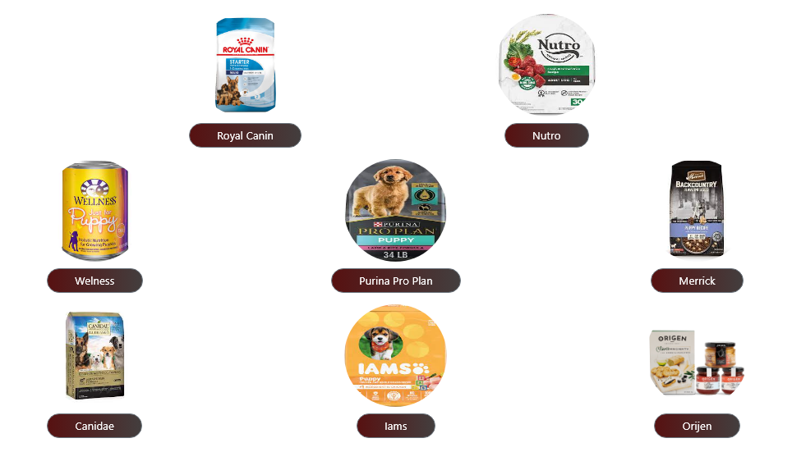

It’s a Puppies and dogs nutrition tips and feed names .



# **Explore the puppy spot**

### **Here are some key points about PuppySpot:**

**1. Online Puppy Marketplace: PuppySpot operates as an online marketplace where individuals**

**can browse and choose from a variety of dog breeds.**

**2. Reputable Breeders: PuppySpot claims to work with a network of responsible breeders who**

**adhere to certain standards and practices. The goal is to ensure that the puppies come from**

**ethical and caring sources.**

**3. Puppy Health and Well-being: The company emphasizes the health and well-being of the**

**puppies they facilitate the adoption of. This includes veterinary checks, vaccinations, and other**

**aspects of puppy care.**

**4. Breed Variety: PuppySpot typically offers a wide range of dog breeds, allowing potential buyers**

**to search for specific breeds or characteristics that fit their preferences.**

**5. Screening Process: PuppySpot has a screening process for both breeders and buyers. This**

**process is designed to ensure that both parties are committed to the well-being of the animals.**

**6. Customer Support: The platform usually provides customer support to assist buyers throughout**

**the process of finding and adopting a puppy.**

**7. If you're considering using PuppySpot, it's important to do thorough research. Read reviews**

**from other customers, ask questions about the puppy's background and health, and ensure that**

**you are comfortable with the breeder associated with the puppy you are interested in.**

**8. Remember that responsible breeding practices and ethical treatment of animals are essential**

**considerations when acquiring a new pet. Always verify the legitimacy of the breeders and**

**ensure that they prioritize the health and welfare of the animals.**



# **Get In Touch With Us**

**If you are looking for information about PuppySpot, a service that connects people with puppies,**

**you can visit their official website or contact them through their customer service channels.**

**Please note that my responses are based on information available up to my last update in January**

**2022, and I do not have real-time internet access to check current details.**

**Here are general steps you can take to get in touch with PuppySpot:**

**1. Official Website:  
 Visit the official Puppy Spot website. You can find information about available puppies, the**

**adoption process, and more.**

**2. Contact Information:  
 Look for a "Contact Us" or "Customer Support" section on the Puppy Spot website. This section**

**often includes phone numbers, email addresses, and sometimes a contact form.**

**3. Customer Support:  
 Reach out to Puppy Spot's customer support using the provided contact details. This could**

**involve calling a customer service number or sending an email.**

**4. Social Media:  
 Many companies, including Puppy Spot, have a presence on social media platforms. Check their**

**official social media profiles for updates and possibly additional ways to get in touch.**

**5. Email Inquiries:  
 If there is an email address provided, you can send inquiries or questions to Puppy Spot via**

**email. Always use official and verified contact information from the company's official website**

**or other reliable sources to ensure you are reaching out to the correct entity. If you have specific**

**questions about Puppy Spot's services, policies, or available puppies, their customer support**

**team should be able to assist you.**



WebPage Footer:

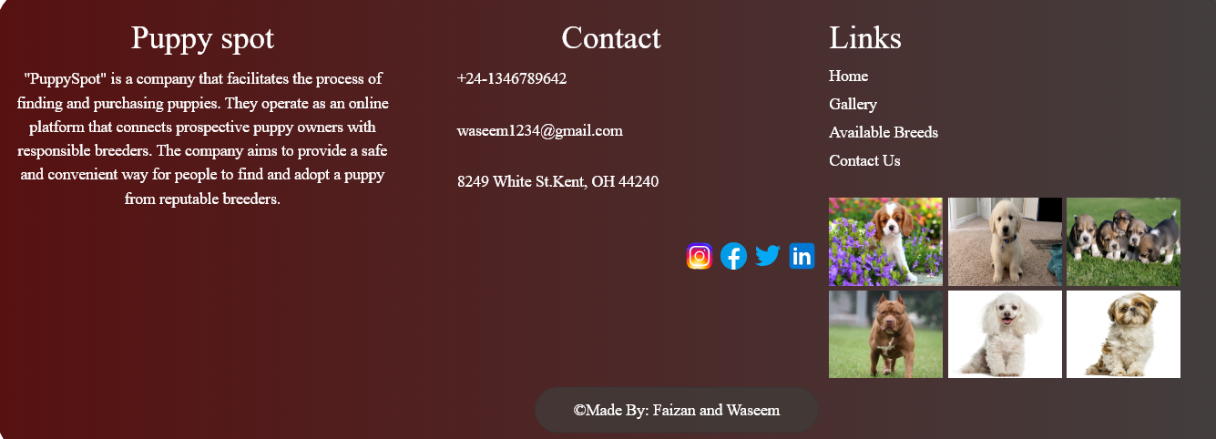

Conclusion

Such contests ought to be held more frequently by the organization

since they are excellent opportunities for potential assessment and

creative problem solving. It was significantly harder because time

allotted was so short. Additionally, we would like to thank our

faculty that contributed to the core as well as the academic for the

competition.

We are really grateful for the time and work of our instructor, along with the rest of the

team members invested in us.

~~~~~ End of the Document ~~~~~~